**UniVersor**

General Summary.

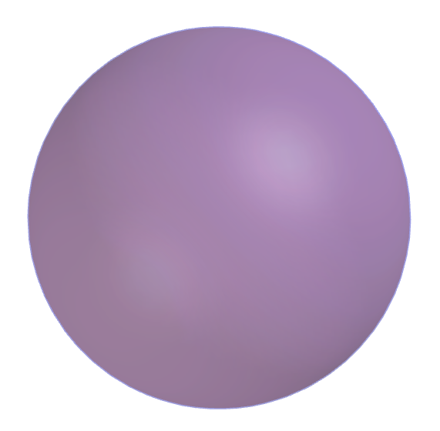

By Matías Bonino.

26/06/2019



Universor Project (or "1V Project") is a project to create a spherical virtual universe, with defined limits and with bodies inside that act under Newtonian physics. The model of this universe described in this report is called "UniVersor", "Universor" or "1V" and is under public domain. In this project a GPL implementation will be done (https://www.gnu.org/licenses/gpl-3.0.html) of UniVersor in JMonkeyEngine (http://jmonkeyengine.org). The project does not need to be centralized and can perfectly be considered as belonging to the Community, with different groups making different implementations to their liking.

In UniVersor there are attractor bodies and not attractors, attractors attract any body gravitationally with a universal gravitation constant of 3.9 * 10 ^ (- 6) $\frac{m^{3}}{kg*s^{2}}$. If a body exceeds the radius of the beginning of the repulsive zone (1 * 10 ^ 8 m) a force is exerted on it that pulls it towards the center of UniVersor given by the following formula.

$$F_{R}=\frac{μ_{R}m}{{r_{R}}^{2}}$$

Where $F_{R}$ is the repulsive force we are talking about, $μ_{R}$ is the standard repulsion parameter and is equal to 1 * 10 ^ 10 $\frac{m^{3}}{s^{2}}$, m is the mass of the body and $r_{R}$ is the distance to the singular radius, the latter being equal to the radius of the beginning of the repulsive zone plus 3.16 * 10 ^ 6 m (so that when entering the repulsive region a force is exerted to accelerate to 1 mm / s ^ 2).

It is possible through a "transformation" to change the shape, mass and volume of a body, but not its density that is the same for everyone.

You can also add propulsion to a body (it will consume energy on a unit of force that you want to apply over time, this depends on the exit speed of the "jet"). This propulsion can be managed with scripts assigned to that body, being able to add intelligence and thus create bots or "NPCs".

Attractors Players

Bodies Creatures

Non attractors Bots (or “NPCs”)

Inert

Features:

_ Universal density (5968.31 kg / m ^ 3, so that the "standard planets" have a terrestrial gravitational acceleration on their surfaces).

_ Universal bounce.

_ Universal cost of converting into propeller per exit speed unit and scripts for its control.

_ Universal transformation time per unit of volume. The mass is not preserved by changing the volume, but its density.

_ It can project a domain or not.

Energy Energy beam (exerts a repulsive force on

Transmision what it touches, determine cost / exit speed

to make an existing body cast it).

Energy ball (explodes on impact with a surface, determine volume / energy).

Gain per unit of time depends on the domain of the faction.

Domain:

When a body is assigned to project a spherical domain (determine cost / volume dominated), it will produce energy (determine power / volume) that can be used by the player, bot or organization that owns the domain. One possibility is that the dominated power / volume decreases quadratically with respect to the distance to the nearest attractor and increases proportionally to its mass. If the domain is so large that at its extremes there are very different gains for domains placed there, then it is necessary to devise a mechanism to lower efficiency. It occurs to me that if it exceeds 100 m radius then the gain is: the radio gain equal to 100 m; plus an extra proportional to the radius minus 100 m, raised to 3/2. If a player passes within the domain his position is tracked. If there are several domains intersecting each other they are deactivated.

Link:

Bond two points on the surfaces of different bodies with a maximum stretch supported that if it is exceeded the link is destroyed. The spring constant and the maximum stretch depend on the energy that was spent in creating it. Each link has a constant length from its creation moment.

Genesis:

In Universor there is a determined amount of bodies of each type: 100 attractors, of which 10 are "standard planets" (spherical attractors with a radius equal to 100 m, in which players could appear if they wanted to add them) and have 100 bots each one on its surface (individual bodies propelled with scripts). In addition, the attractors are fractally distributed and have a small initial velocity so as not to collide with each other.

Why is the universal density and the universal gravitation constant defined in this way?

So that the calculations are easier, since the standard gravitation parameter of the "standard planets" (radius equal to 100 m) of just 97500 m ^ 3 / s ^ 2, its gravitational acceleration on its surfaces is as the terrestrial and the density can be approximated to 6000 kg / m ^ 3. There is no other reason why I chose that way, it can be done in other ways.

Why this number of bodies?

So that the computational resources are not exhausted and a good performance is maintained.

Why can not density be changed and is it the same for all bodies?

I made this decision simply because I wanted to maintain a certain simplicity in the model by making the mass of a body depend on its volume in the same proportion for all bodies. Simplicity also justifies the universal bounce. There are no more reasons to justify it.

How are the bots?

An idea that occurred to me is that they are cubes or balls propelled that go with great speed towards the player and kill him from the impact, breaking the links that constitute the ragdoll. By killing the bots they become inert bodies, which can be used by the player. They can reproduce by slowly converting an inert body into a bot. Does offspring have mutations in speed, mass, intelligence and speed of reproduction? The energy is taken out of their own domains. They can live in groups.